* 1. I can investigate a range of development environments

There are different standards of environments which are used in the industry, each environment has its own unique purpose. most of processes start with ‘development stage’ and end with ‘production stage’.

Development stage:

The development environment is used to build websites/ application, this where most of the work developers create is completed. The development environment is usually set up on local computers, and work is facilitated by git repositories.

Test stage:

A testing environment is a combination of hardware, software, and data configuration. There are many types of test environments, which is used depending on the application under testing. Types of test environments, integration, performance, security and chaos.

Production Stage:

Production environment is the final phase in the software development process, updates are pushed live to the

intended users, this is the environment where the end user can see, experience, and interact with the new product, it is the work that is ready to be publicly available, and only the most thoroughly tested code ends up here.

Project methodologies used in software development

Software development methodology is a structured process technology, used when working on a project. Software development methodology provides a platform for developers to work together and more efficiently. There are many software development methodologies used, most of the methodologies can be categorized as either a waterfall, iterative or continuous model. Some that are more commonly used are Agile, DevOps and Waterfall development methods.

Agile method:

In all agile methods, teams develop the software in iterations that contain mini increments of the new functionality. There are many different forms of the agile development method, including scrum, crystal, extreme programming (XP), and feature-driven development (FDD).

Pinterest.com

DevOps method:

DevOps is not just a development methodology but also a set of practices that supports an organizational culture. DevOps deployment centres on organizational change that enhances collaboration between the departments responsible for different segments of the development life cycle, such as development, quality assurance, and operations.

Medium.com

Waterfall method:

The waterfall method is the most traditional software development method and is considered outdated. The waterfall method is a rigid linear model that consists of sequential phases (requirements, design, implementation, verification, maintenance) focusing on distinct goals. Each phase must be 100% complete before the next phase can start. There’s usually no process for going back to modify the project or direction.

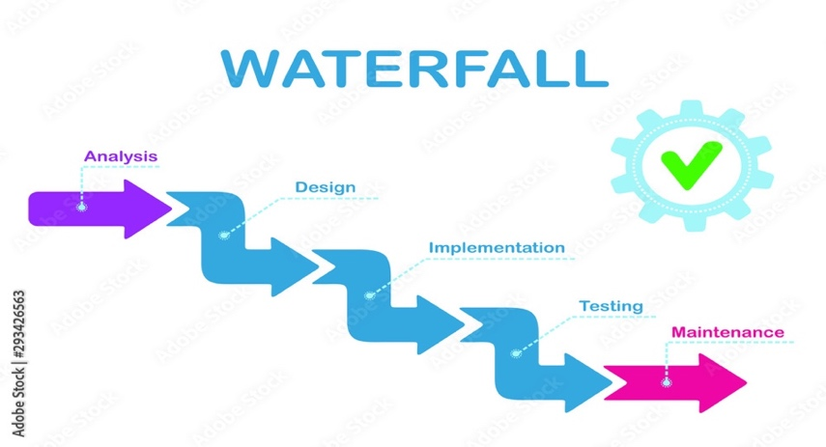

Stock.adobe.com

Some comparisons in the Agile and waterfall methods:

Plutora.com